SITE MANUAL
RESEARCH STATION DANEBORG
2020

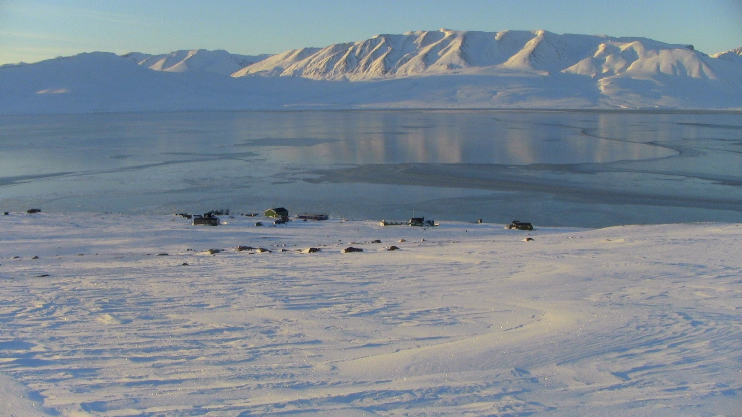

Arctic Research Center
Department of Bioscience
Aarhus University

Contents
Introduction 4
Access to Daneborg 4
Visa 4
Insurance 4
Travel to Daneborg 4
Travel plan 6
Luggage and cargo bringing with you on the travel 6
Staying in Daneborg 6
Station fee 6
Personal packing list 7
Clothes 7
Tickets, papers and more… 7
Security clothing 7
Things you don’t need to bring 7
Equipment to Daneborg 8
Equipment send to Daneborg by ship (Only possible for projects starting mid August and later). 8
Packing and labeling 9
Equipement send to Daneborg by air 10
Dangerous goods 10
Lithium Batteries 10
Biological resources 10
Packing and labeling 11
Safety on the Daneborg field Station 11
You need to bring 11
We already have on the station 11
Furthermore in the boat Aage V. Jensen 11
Firefighting 11
First aid and medical assistance 12
Wildlife at Daneborg 12
Sirius Daneborg – Military area 12
Local guidelines for stays at Sirius Daneborg 13
Technical information 13
Communication 14
VHF 14
Iridium 14
The Daneborg station 14
Boat House 15
Residential house 16
Communication 17
Water supply 18
Tide 18
Laboratory facilities 18
Equipment in the wet lab 18
Equipment in the dry lab 19
Equipement in the boat hall: 19
Field equipment 19
Field equipment on the station 19
Local transportation – Boats, Airboats and Skidoos and so on. 20
Transport at the station 20
Transport into the field – Young Sound 20
Winter (October-July) 20
Summer (July-October) 20
Shipping cargo back to DK/Nuuk/Canada 21
Shipping by air 21
Shipping by ship 22

Introduction
This manual will provide information about conducting fieldwork in the Young Sound area with the Daneborg station as your base. The Daneborg field station is located at 74°18N, 20°13W and is a part of the Zackenberg station, 25 km further into the Young Sound fjord system. The Daneborg field station is located just next to the Danish Military Station Daneborg, where the Sirius Patrol also has their headquarters. This makes conducting fieldwork much easier at the Daneborg field station in comparison with the Zackenberg Station. The ship will anchor in Daneborg where we can buy electricity and drinking water (in the summer). We also have access to their landing strip, and subsequently have good neighbors from the Sirius Patrol Staff.
The Zackenberg website www.zackenberg.dk provides a lot of information. This manual will not repeat the information but just link to the information when relevant.

Access to Daneborg
To access Daneborg you require permission from the Greenlandic authorities. The administration of this goes through the Zackenberg secretariat where you can access the application and forward it to the secretary. See www.zackenberg.dk.

Visa
If you are not Danish, EU, US or Canadian citizen you maybe have to apply for Visa to the Schengen area (Island) and to Greenland. Ask Egon (erf@bios.au.dk) for more information on the procedure. For Canadian citizens, please contact the CEOS office for assistance with the timelines or procedures.

Insurance
The Greenlandic government requires that you have SAR (search and rescue) insurance to get a permission to go into the National Park.
If you are currently employed at the Institute of Natural Resources in Nuuk you should have it already.
If you are employed at Aarhus University or any other Danish or foreign institution with self-insurance, you will have to fill out appendix D at the Zackenberg homepage www.zackenberg.dk, and include it with your Daneborg application.
All others need to buy insurance from an insurance company. Request further information on this from Egon.

Travel to Daneborg
There is only one option to access Daneborg. You must go to Iceland and with a connecting flight through Akureyri in northern Iceland where you can fly to Constable Point with a chartered flight. From Constable Point, you will continue to Daneborg.

Typically, the flights from Akureyri use small TwinOtter planes, however, in the summer, when there are more scientists in East Greenland, the flights to Constable Point will eg. be a Dash 8 or a Fokker 50. From Constable Point to Daneborg you will always fly by Twin Otter because it can land on the short landing strip in Daneborg.

On the map below you can see the route:


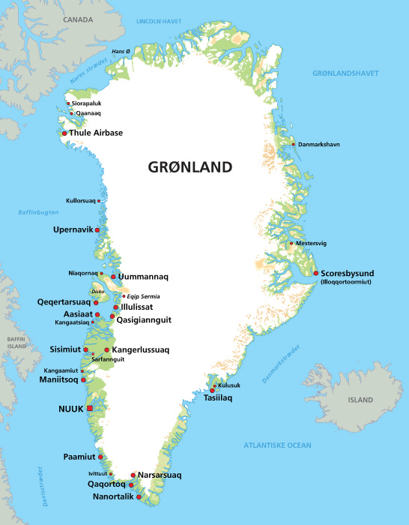
Akureyri -> Constable Point:
800 kg allowed on a Twin Otter
Constable Point -> Daneborg:
Max 1300 kg allowed on a Twin – including 8 pax Otter
From Europe
From US/Canada
Keflavik Airport
Reykjavik
Akureyri
Constable Point
Daneborg

Normally flights to the east coast of Greenland are on Tuesdays (This day of week can be changed from week to week – see tentative flight schedule at https://g-e-m.dk/gem-localities/zackenberg/access/). You have to arrive in Akureyri the day before your flight to Greenland. The flight to Greenland typically leaves in the morning between 9:00 – 10:00 AM. Please verify the time your flight will leave for Greenland, the day you arrive in Akureyri. Depending on the type of plane, it will take 1-2 hours to get to Constable Point on the east side of Greenland. If you are on a Fokker or Dash from Akureyri, be prepared for a long delay before you continue on the TwinOtter. After approximately a 2 hours flight in the TwinOtter, you will arrive in Daneborg.

Travel plan
Normally the Zackenberg logistics order all the flight tickets for you, all this will be done automatically from the information in the application, and Kibba can rebook you flight out of Iceland if some delays happen from Greenland. Booking through Zackenberg logistics also include hotel in Akureyri the night before leaving to Greenland and the night before leaving Iceland on the way back.
In Daneborg you will have to walk approximately 500m to access the field Station.

Luggage and cargo bringing with you on the travel
Since the TwinOtter planes have limitation on the capacity you are only allowed to bring 20 kg as personal luggage. Every kg above this limit will be charged as cargo.
Since the TwinOtter planes have limitation on the capacity you cannot bring any cargo with you on the plane without agreement from Egon/Zackenberg logistics. If you have cargo in Akureyri without agreement from Egon/Zackenberg logistics, it will be left behind in Akureyri due to the space on the plane.
Cargo to Daneborg – see the procedure Equipment send to Daneborg by air

Staying in Daneborg
Once in Daneborg, there will be a mandatory introduction to the station (Introducing in accordance to the Welcome manual in appendix 2). After the introduction, you will be able to start unpacking your personal effects and research equipment.
During your stay in Daneborg, there will be a scientific leader to coordinate the different projects to enable everyone to carry out their projects.
In the case of bad weather, the logistic leader/scientific leader that makes the decision if it is safe to work on the ice or from the boat (normally below 8m/s)
Prior to the end of your stay in Daneborg, you will have to finish your project two days prior to leaving for home. The last day is for packing and labeling your equipment for return. See the section for sending cargo back.
On the day you are leaving Daneborg, you cannot plan to do anything else other than attend to your personal luggage. It’s not possible to tell you what time of the day you must be ready for pick up at Daneborg, but if the plane overnights in Daneborg/Zackenberg, you will probably leave in the morning, otherwise it can be any time of day, normally not later than 3 pm. From Daneborg you fly to Constable Point, either with the Fokker or Dash to Akureyri/Reykjavik.

Station fee
While you are in Daneborg your project has to pay a station fee for staying at the station updated price list can be found at https://g-e-m.dk/gem-localities/zackenberg/access/. This station fee cover
- Living in the house
- Safety equipment on the station (Signal pistol, Riffle, fire alarm and so on..)
- Heating of the house and lab.
- Use of electric power and water
- Use of lab in the house and boathouse
- Food – but you have to be willing to take turns preparing the food
- Sheets, bedding and towels for 10 persons
- Kitchen devices and all kind of equipment needed for cooking

Personal packing list
You need to bring the following personal belongings to Daneborg (and maybe a little more… - but max 20 kg in total):

Clothes
- Clothes that are versatile, durable and comfortable
- Warm jacket – Canadien Goose or alike
- Warm pants
- Warm sweater or fleece (windblock)
- Gloves, hats, balaclavas and neck warmer
- Warm socks
- Sunglasses
- Boots – warm
- Rubber boots
- Normal clothes and underwear
- Indoor footwear to use inside the residential house (boots not allowed)
The actual needs depend of person and depends on period in Daneborg. Sometimes in July-August it can be 10-15°C and sunshine, but in March-April it can be -30°C and windy…

Tickets, papers and more…
- Tickets to Iceland (You should receive them from the Zackenberg secretary in an email including the domestic flight schedule and your accommodation in Iceland on the way to/from Daneborg) – domestic flights in Iceland and to Greenland are non tickets flights – You are just registered in the computer, so you just have to present passport. Please check the email from Zackenberg secretary carefully to ensure you have the needed accommodation and all flight information.
- Passport
- Insurance-card and/or SAR insurance
- Creditcard – for use in Iceland – Can’t use it in N.E. Greenland
- Mobile Phone – for use in Iceland and Constable Point (It’s expensive) – Can’t be used in Daneborg
- Papers for your project.
- Personal computer – Don’t bring your PC from the cold into the warm and turn it on. It will die because of the condensation of moisture on the boards. Wait 20 minutes before turning on.
- Necessary personal toiletries
- Ski goggles (Depending of season)
- Multitool (Victorinox or Leatherman) – good to have but not a must – remember not to bring it in the hand luggage on the flights.

Security clothing
See the section “Safety on the Daneborg field station” below

Things you don’t need to bring
- Sleeping bag
- Sheets, bedding
- Towels

Equipment to Daneborg
There are two options to send cargo to Daneborg – By ship and by air.
Equipment send to Daneborg by ship (Only possible for projects starting mid August and later).
Once a year, there is a container ship going to Daneborg where there’s an opportunity to send all kind of cargo.
The ship will leave Aalborg, Denmark late July and will arrive in Daneborg the first half of August – often around August 10th). The schedule will vary from year to year.
Procedure:
Contact Egon Frandsen on email erf@bios.au.dk and provide a list indicating what kind of cargo you have. Use the “List of cargo for Daneborg” in Appendix 1 :
Consider
No
- Limited size
- Limited weight
- Price
Equipment send by air
Equipment send by ship
Yes

There is one ship to Daneborg every summer
The ship is chartered by the Danish Military and any booking have to go to Egon first, who will book accordingly with the military procedure (this can change from year to year)
Booking to:
Egon Frandsen on mail erf@bios.au.dk
- Small cll.
- Pallets
- Containers
- All kind of equipment
- Dangerous goods
- Frozen goods
- Refrigerated goods
- Almost everything

ok

What can be send?
Go to the Air Freight section

Deadline for sending goods by ship
June 1st: Deadline for booking goods for the ship to erf@bios.au.dk
June 15th: Deadline for delivery of goods to Egon Frandsen:
Arctic Research Center
Aarhus University
Ole Worms Allé 1, Building 1135
8000 Aarhus C
Att. Egon Frandsen
July 1st: Deadline for delivery of large cargo directly to the ship in Aalborg – only after booking on erf@bios.au.dk before June 1st. Egon will provide you with delivery address.

Deadline

The mail to Egon on erf@bios.au.dk must be attached with the file: “List of cargo for Daneborg” in appendix 1
We will not be able to book without the information

Information to provide

Packing and labeling
You must:
- Pack you equipment in boxes.
- Page 1 in Appendix 1 you must be filled in prior to sending cargo by ship. Save Appendix 1 to your computer and send the list to erf@bios.au.dk. It is very important that the weight and volume is correct.
- Then you will receive labels to your boxes listed in Appendix 1, with a unique number so we are able to track every single box to Daneborg.
- Attach the labels to each boxes, and fix them to the pallets
- Attach Appendix page 1 outside the packing film on the pallet.
- Finish the pro forma invoice on your cargo in Appendix 1, and send it to the shipping company and to Egon
- Return any transport document for the transportation to Egon erf@bios.au.dk with booking number or tracking number from the shipping company
- Page 2 in Appendix 1 is the Pro forma invoice for your cargo – will fill out almost automatically when you fill in page 1 in the appendix 1.

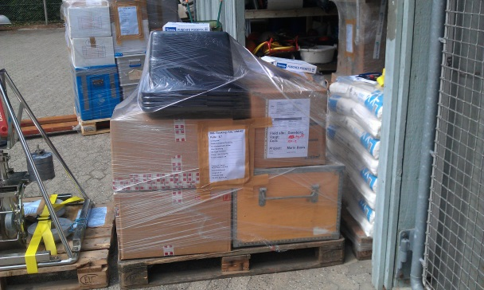 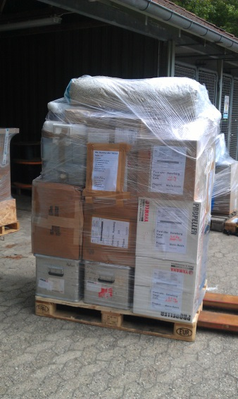
Cargo packed before sending to Daneborg by ship
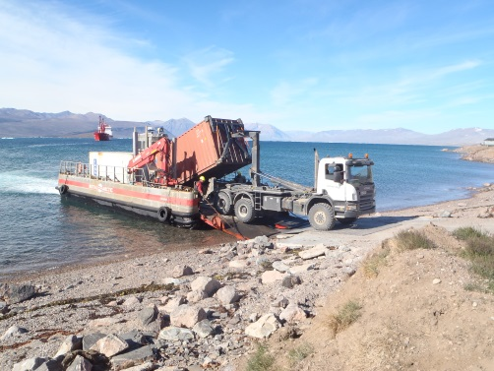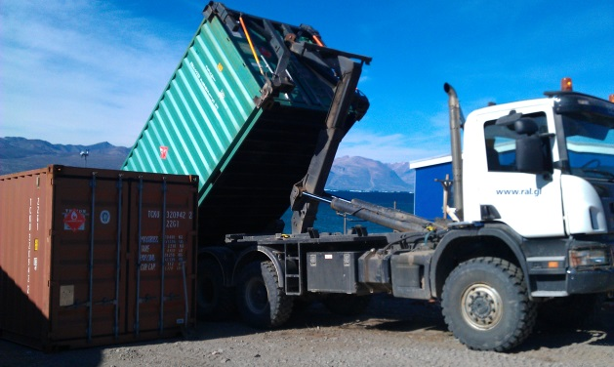
Photo: Henrik Spanggaard Munch
Cargo arriving in Daneborg

Equipment send to Daneborg by air
There is no fixed deadline on sending cargo by air to Daneborg. However, due to inflexibility of cargo on the planes from Akureyri to Daneborg, your cargo must be in Akureyri no later than 1 month before you arrive yourself.
Procedure
Contact Egon Frandsen on email erf@bios.au.dk and provide a list of the kind of cargo you will send – using the “List of cargo for Daneborg” in Appendix 1.
Appendix 1 must be send by mail to Egon erf@bios.au.dk prior to sending cargo to Akureyri/Daneborg:
- Page 1-2 in Appendix 1 must be filled out prior to sending cargo to Akureyri.
  - No boxes must exceed 50 kg each – due to handling by hand along the east cost of Greenland
  - Don’t pack any boxes in Fiberboard, they won’t stand the handling to Greenland
  - Dangerous goods are often packed in fiberboard boxes. They are UN-boxes and able to withstand rain for several hours. But it would still be a good idea to have plastic/wood/metal boxes outside and then labeled with “Overpack” according to the IATA rules
Save Appendix 1 to your computer and send the list to erf@bios.au.dk. It is very important that the weight and volume is correct, because these values are used for loading the plane with the possible payload.
- You will receive labels to your boxes listed in Appendix 1, with a unique number so we are able to track every single box to Daneborg.
- Attach the labels to each boxes. You can send your cargo on pallets to Akureyri – size of pallets depending of the air fright route or sea freight route you will use – but from Akureyri the pallets will be split up in single boxes for further transportation. Therefore, every box must be labelled separately.
- Return any transport document for the transportation to Egon erf@bios.au.dk with AWB number or tracking number from the shipping company
- Page 3 in Appendix 1 is the Pro forma invoice for your cargo – will fill out almost automatically when you fill in page 1-2 in the appendix 1.
Remember it is quite expensive to send your equipment by air (See actual price/kg at https://g-e-m.dk/gem-localities/zackenberg/access/.)

Dangerous goods
If any of the cargo to Daneborg is classified as dangerous goods, you have to fill out dangerous goods shipping paperwork and pack according to the IATA guidelines for the dangerous goods you have. This must be done by someone with the authority to do so – valid IATA certificate. Please ask Egon for more information (DK) or Emmelia Wiley (CA).

Lithium Batteries
Lithium batteries are dangerous goods. Please contact Egon or Emmelia. Be aware that lithium batteries marked with CAO (Cargo airplane only) cannot be transported to Daneborg, because there are no flights with cargo only. Very often lithium batteries can be packed different so they are allowed on passenger flights.

Biological resources
You are not allowed to transport any rocks, water, ice or biological samples out of Greenland without permission. Fortunately, it is easy to get the permission. You need to fill out the application in appendix 3A (Example in Appendix 3B and licence in Appendix 3C) and send it to ISIIN@nanoq.gl at the Greenlandic authorities with cc to erf@bios.au.dk.dk . You must include this permission when transporting your samples. Otherwise, you risk that your samples will be confiscated by the Greenlandic authorities when you leave Greenland and you will receive a fine. Consult Egon if you need more guidance on this.

Packing and labeling
You must:
- Pack you equipment in boxes (not Fibreboard boxes) with a single box weight below 50 kg
- Dangerous goods must be packed according to the IATA rules. No boxes must carry the CAO label (Cargo Aircraft Only), because there are no Cargo only flights to Daneborg.
You cannot send cargo with this label to Daneborg
- Attach the cargo label with tracking number you get from Egon
- Finish the pro forma invoice in Appendix 1, and handle it to the shipping company and to Egon

Safety on the Daneborg field Station
There is some safety equipment in Daneborg, and some you have to bring by yourself. The list below shows what to bring and what’s already there.

You need to bring
- Survival suit, if you are going to work on the ice outside the Daneborg station
- Survival suit or floating suit, if you are going to work from a boat on Young Sound
- Warm clothing or weather appropriate clothing, depending on the time of year
- Portable GPS

We already have on the station
- Signal pistols (2 project + 3 in-house)
- Riffles (3 project + 3 in-house)
- VHF radio (5)
- Iridium phones – portable (2)

Furthermore in the boat Aage V. Jensen
- VHF (1)
- Beacon (1)
- GPS with map (1)
- Lifesaving raft for 6 persons
- Life jackets for 6 persons
- emergency flares
Shortly after arrival, everyone must practice shoot with the signal pistols and rifles to familiarize themselves with the weapons.

Firefighting
In the residential house there are
- Fire alarms in all rooms
- Firefighting stations (water)
- Fire blanket in the kitchen
In the boat house there are
- Firefighting stations (powder extinguisher)
In the Aage V. Jensen boat there are
- Powder extinguisher

First aid and medical assistance
Every person arriving in Daneborg must have attended a First Aid course. First aid kits are available and further medical assistance is provided be the Sirius patrol. To obtain SAR insurance, you must sign (confirm) that you are in good health. You are allowed the use of personal prescribed medication, which you must bring yourself, and still access the station. You will have to fill out Appendix A on:
https://g-e-m.dk/gem-localities/zackenberg/access/

Wildlife at Daneborg
At the Daneborg station, and in the Young Sound/Tyrolerfjord area, you may encounter wildlife. Typically, it is only polar bears and musk ox you need be aware. In the summer, you also need to be aware of walruses. According to national park rules, you must keep a distance of 500 meters from walruses. In addition, you are not allowed access to Sand Island in the summer when walruses are lying on the beach without special permission.
You are not allowed to shoot any wildlife in N.E. Greenland with the exception of self-defense. Please refer to the Zackenberg Site manual for more specific guidelines on animals and their behavior, especially the polar bear and musk ox. See www.zackenberg.dk

Sirius Daneborg – Military area
When you arrive in Daneborg you are entering a military zone and there are rules you need to follow. The Sirius Patrol is the local authority.
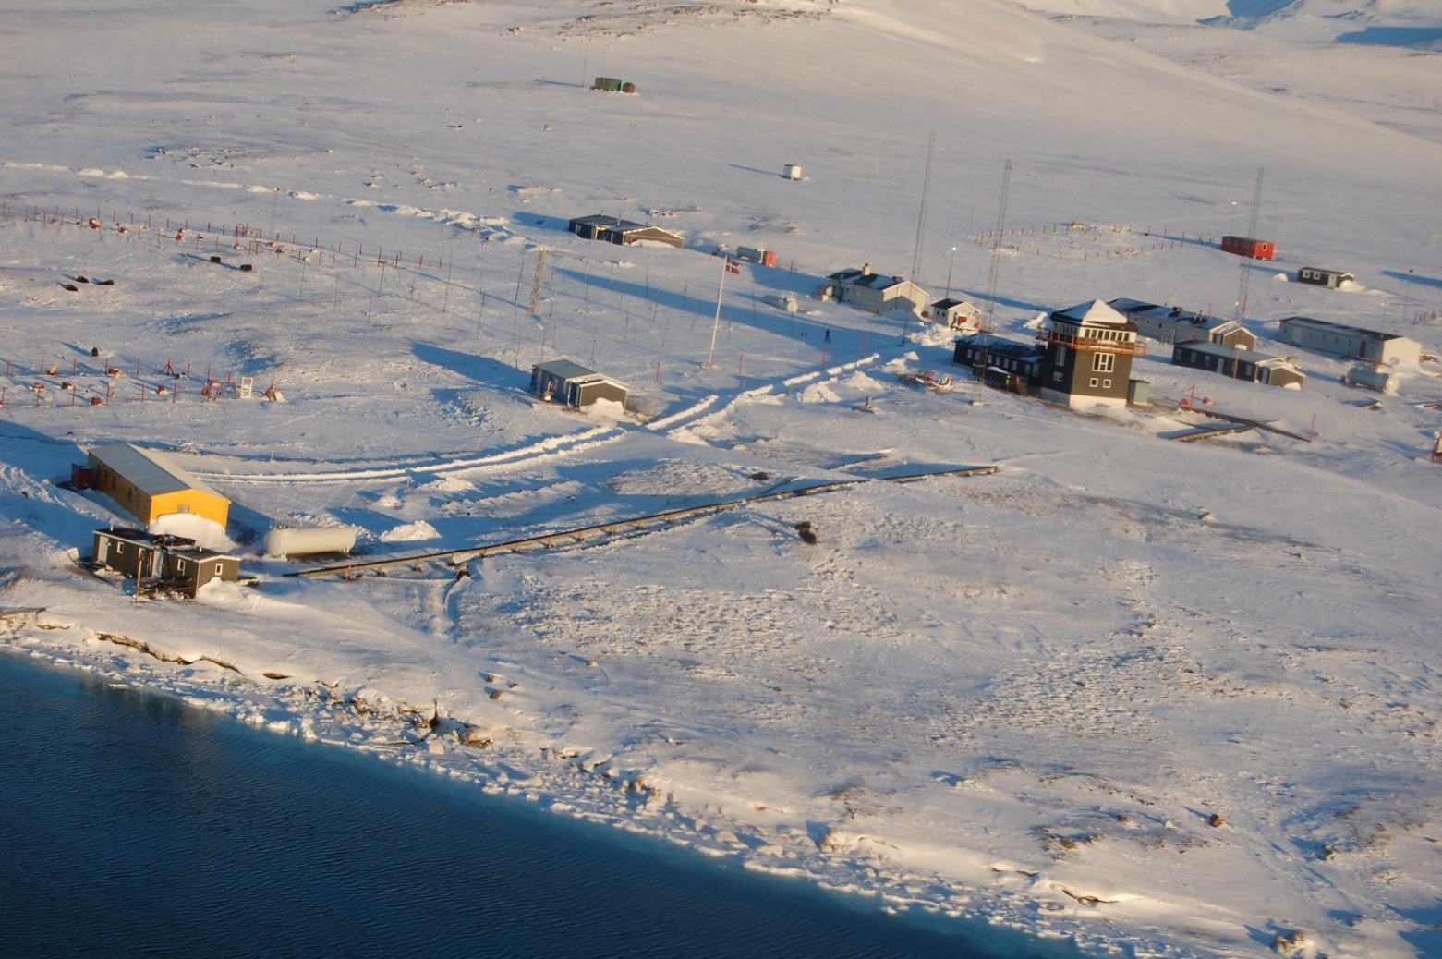
Sirius Patrol Station
Daneborg Research Station
Landing stribe

Local guidelines for stays at Sirius Daneborg
  - All activities conducted on the station premises must comply with the rules and regulations set by the Sirius leader (LD SIR)
  - Activities outside the station premises require permission from the Department of Infrastructure and Environment and GEM
  - When driving on the station premises, vigilance must be exerted at all times toward people and animals. The speed limit is 30 km/h
  - Entry to buildings marked “Forsvaret” (Defense) is prohibited
  - Littering is prohibited
  - The use of tents throughout the station premises must comply with the rules and regulations set by the LD SIR
  - Urinating and defecation are restricted to the toilet facilities in SIRIHUS
  - Walking/driving on or across the runway is prohibited
  - Walking/driving on the apron is only allowed when loading/offloading planes
  - Smoking is prohibited on the apron, as well as near fuel depots and filling stations
  - Smoking indoors is prohibited
  - Cigarette butts etc. must be placed in the bins
  - The Defense personnel at Daneborg have police authority throughout the premises and can thus order inappropriate conduct or activities to cease immediately
  - At any time, the LD SIR maintains the right to impose additional restrictions on visitors’ stay at Daneborg

Technical information
The power supply at the station is 230V, 50Hz AC power. We have 3 converters from 230V to 110V.
The plugs are Danish standard plugs

Communication

VHF
Local communication is by VHF radio on channel 16 as a call up channel. Once into the conversation, it is a good idea to switch to another channel for personal communication, then return to channel 16 when your conversation ends.
It’s possible to use VHF at the station to communicate with people working in Young Sound. Outside Sandøen and inside Zackenberg, it’s not possible to reach people on VHF from the station. Communication to the Zackenberg station and to the Sirius Patrol is possible on VHF. From the Zackenberg station it’s possible to reach people working a little further into the fjord system, up to Lerbugten. 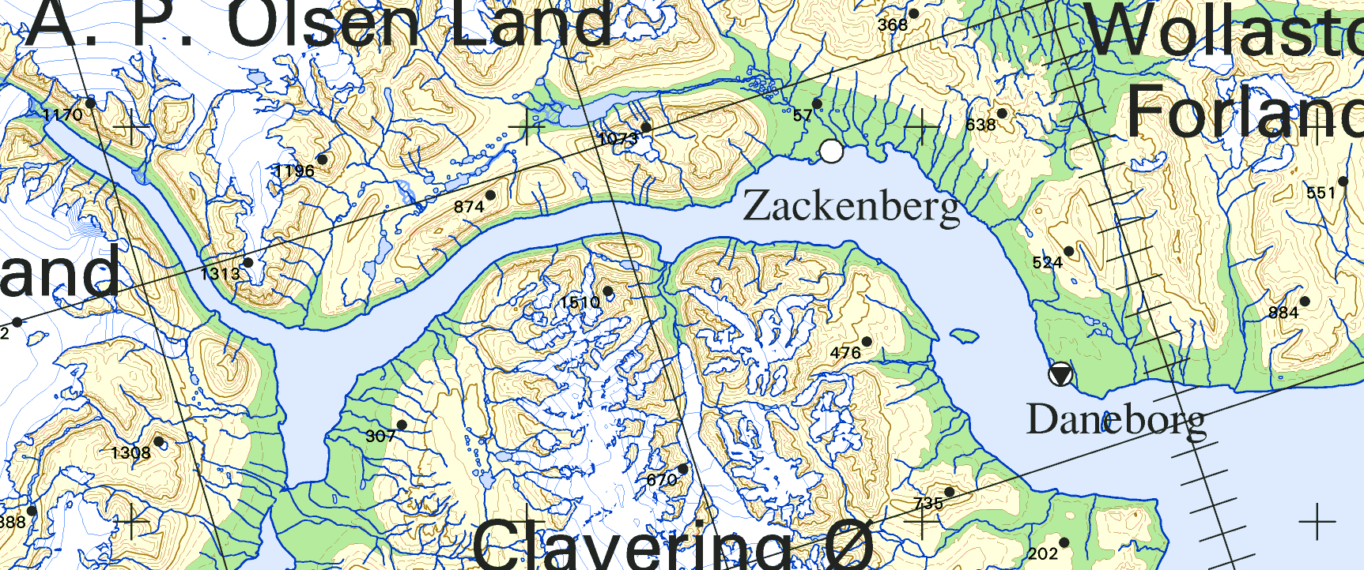
Iridium only

Iridium only

VHF area

Iridium
For communication outside of the station area, we have an iridium system. For safety reasons, we always bring portable iridium in the field which can reach all over the Fjord system.

The Daneborg station
The Daneborg station has essentially two buildings – the boat house and the residential house. Beside these, there are a few old buildings from earlier times when it was weather station, including some containers where we may store equipment.
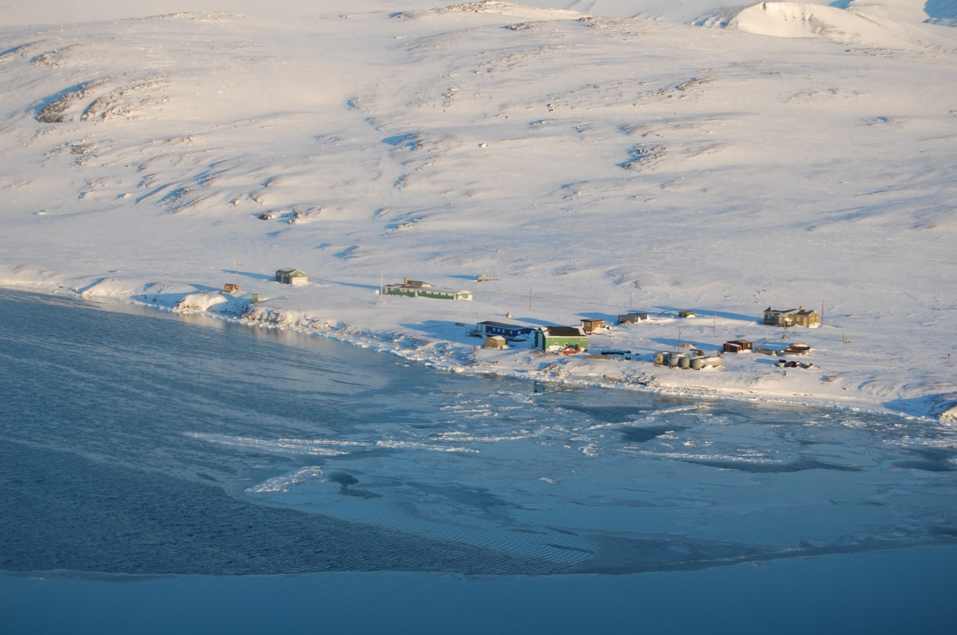
Photo: Leif Riemenschneider
Sirius Patrol station
Old weather station
Residential house
Old boat house
Boat house

Boat House
The boat house is approximately 150 square meters and contains a dry laboratory, about 40 square meters. A boat house occupies the remaining area where there is some storage and space for 3 boats.
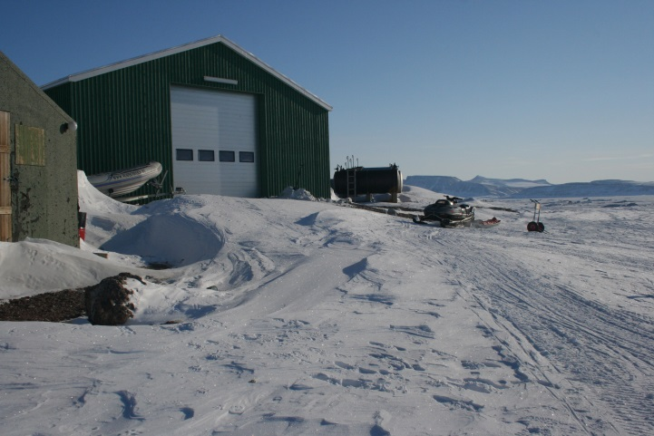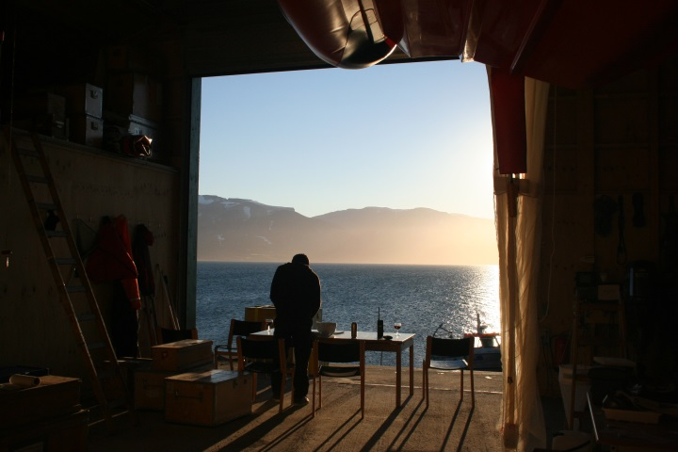
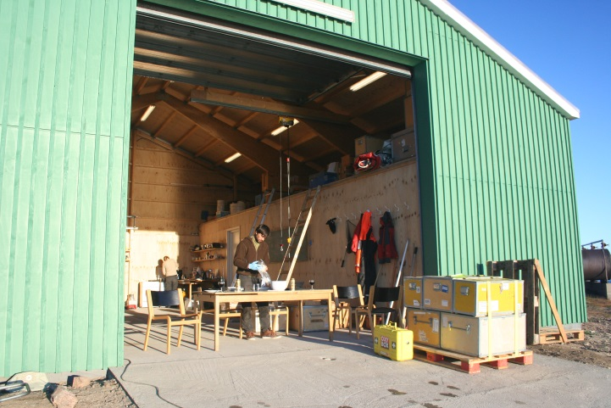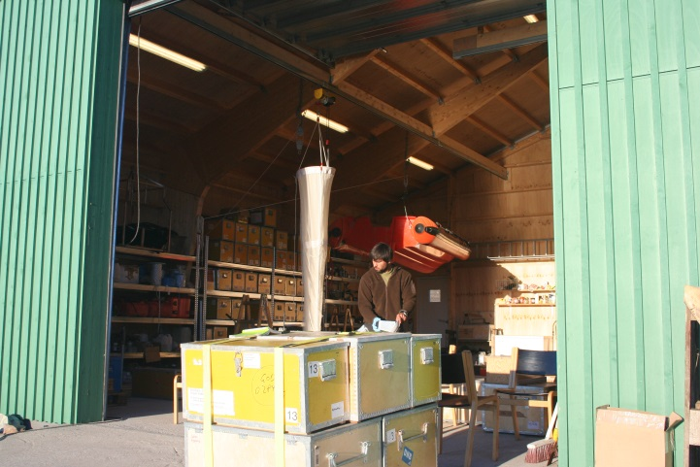
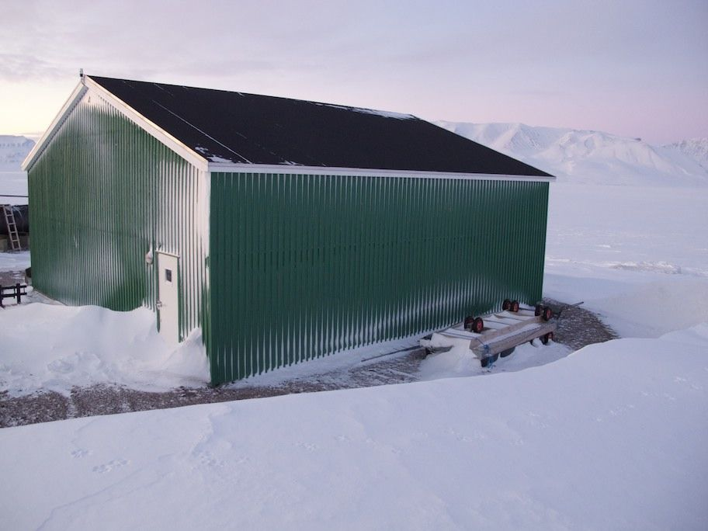
Photo: Søren Rysgaard

Residential house
In the residence, there is a small wet laboratory, a storage room for food and household items, 5 rooms with double occupancy each, a bathroom, a toilet, and combined living room and kitchen.
Beside of this there is a technical room. Se the drawing below – sorry the labels are in Danish!
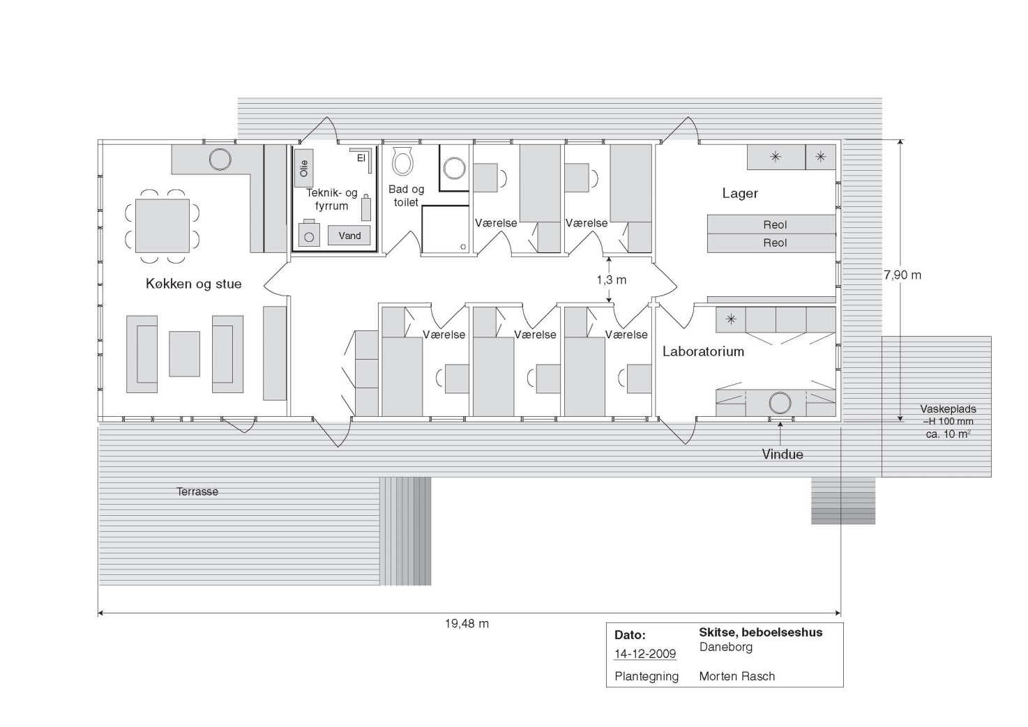
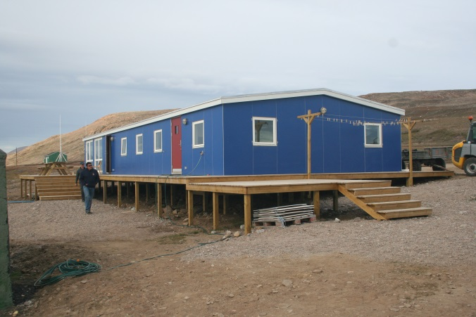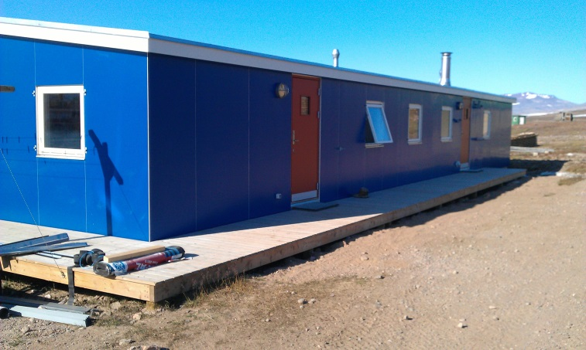
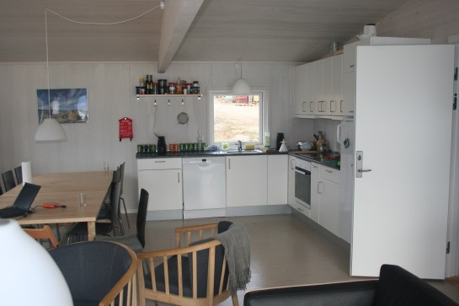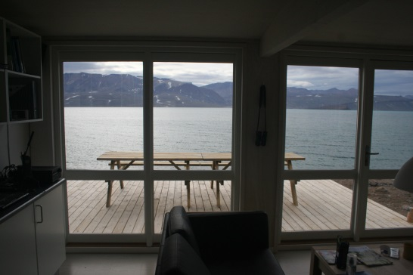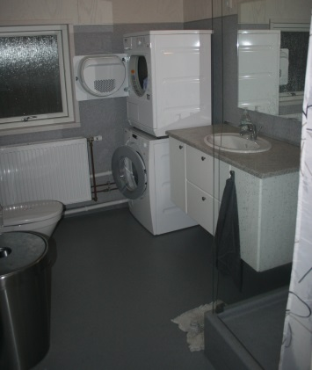
Living room and kitchen Living room and sight to Young Sound Toilet and bath
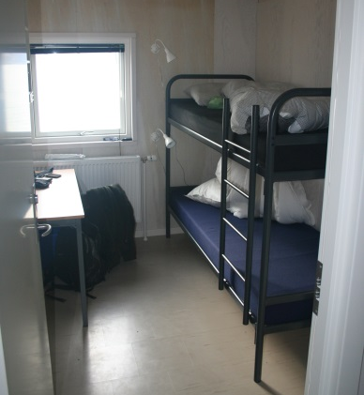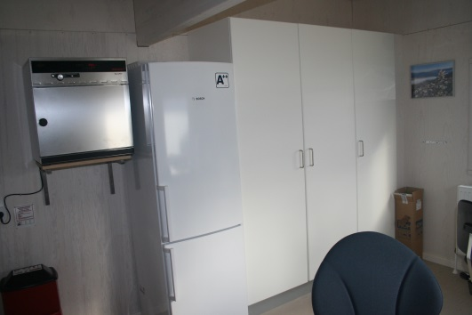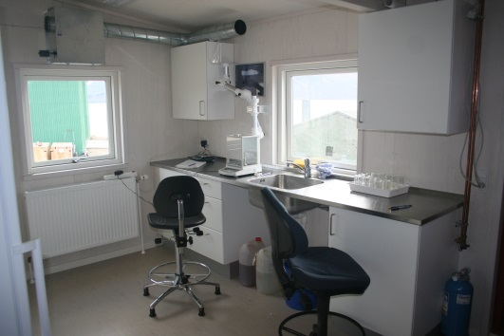
Sleeping room Laboratory Laboratory
While staying at the Daneborg station, you are expected to take turns cooking, cleaning, and general maintenance.

Communication
It’s not possible to use your normal mobile phone in Daneborg. But it’s possible to reach out to the world by iridium systems. We have 2 portable iridium phones to carry in the field for security reasons and an Open Port iridium system where it’s possible to send and receive emails. You are not able to check your normal email home at the office, but the email address daneborg@onsatmail.com is the one to use in Daneborg. Since it’s expensive to send and receive on the iridium there is a limit on the mail size on 1MB. Mails above this size will be rejected.
The price for sending and receiving mails will be 20 US$/MB – please limit the use of attached files.
The price for using the iridium to call home will be 2 US$/minute.
The logistics staff in Daneborg will show you how it works, and there will be a list to note when you have used the iridium system – see appendix 4
The iridium numbers to the station and the contact information to other stations along the east cost of Greenland will be available in Daneborg
Water supply
During the period where there is no running water, the water supply is by melting snow, which is time consuming and limits the amount of available water.
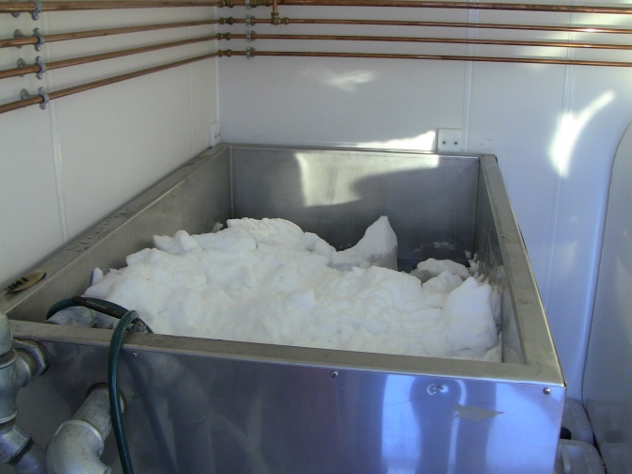 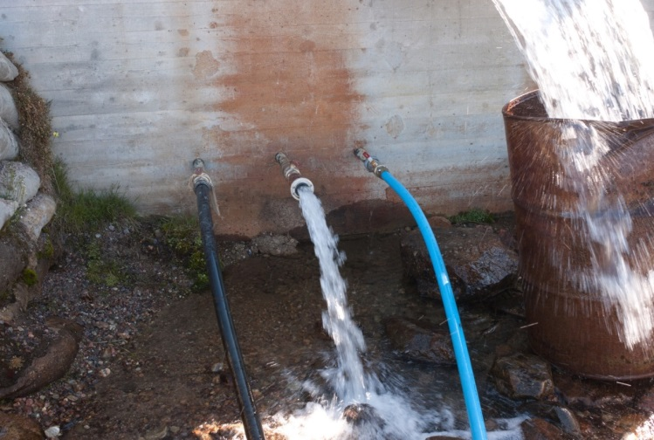
Winter Summer
In the summer time we have water supply from the Sirius Patrol water pond.

Tide
The tide in Daneborg is between 0.8-1.2 meter depending of the phases of the moon. There will be a tide table in the residential house

Laboratory facilities
The dry lab in the heated part off the boat house is very useful for working with instruments, preparing equipment for deployment in the field, processing data, and a variety of other required tasks.
The wet lab in the house is for all kinds of analysis. This lab is also heated.
Equipment in the wet lab:
- Drying oven
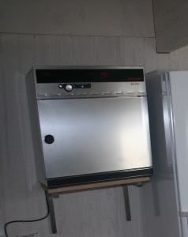
- Balances
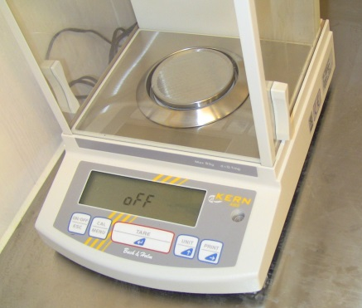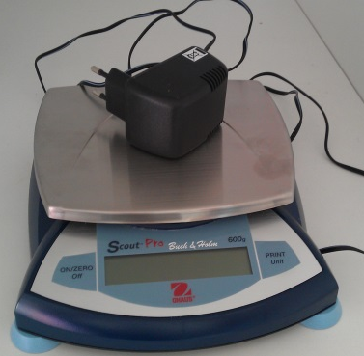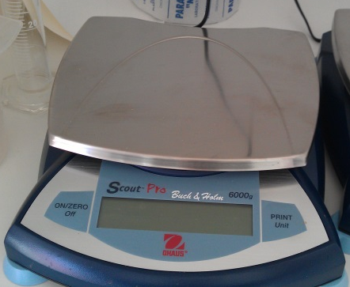
63g, 5 digits Max 600g, 2 digits Max 6000g, 1 digit
- Milli-Q water
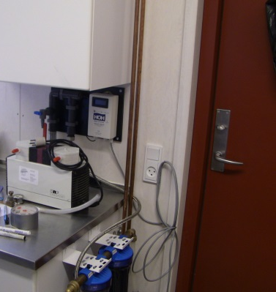
- Pumps for filtration

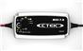
Equipment in the dry lab:
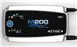
- Battery charger 230V -> 12V (4 CTEK MXS 7.0) – For batteries on 14-150AH
- Battery charger 230V ->12V (1 CTEK M200) – For batteries on 28-300AH

Equipement in the boat hall:
- Display freezer (1)
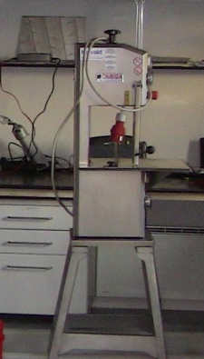
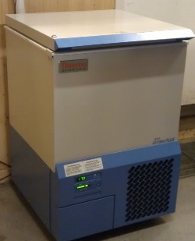
- Normal freezer (3)
- -80°C freezer
- Bandsaw, Stainless Steel (1)
BandSaw | SE 165
Blade | 1650 mm
Cutting Capacity | 240mmx190mm
HP | 1,5
Electrical | 400V

Field equipment
There is some standard equipment at the station but, in general, you have to provide your own equipment
Field equipment on the station:
- Haps
- Kajak sampler
- Niskin water sampler
- Auger (25 cm), engine
- Tripod
- Generator 2000w Honda (2) 12V and 230V output
- Generator 1100w (1) 230V output
- Generator 2300w (1) 230V output
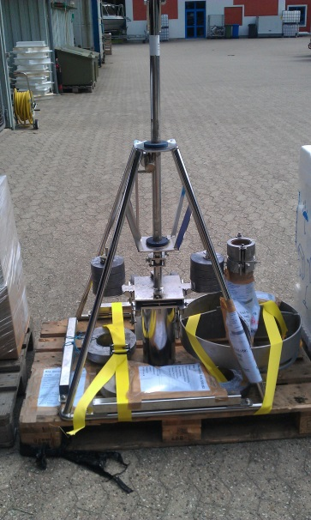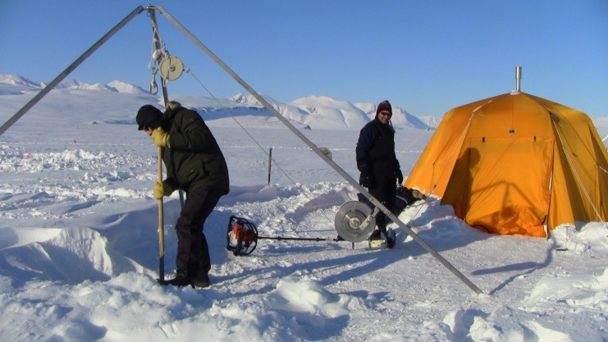

Local transportation – Vehicles and Boats

Transport at the station
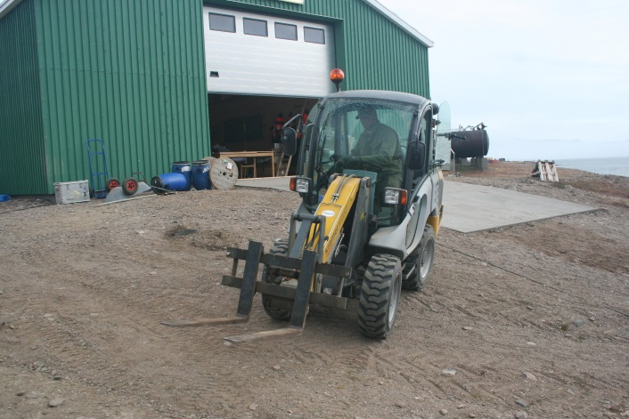 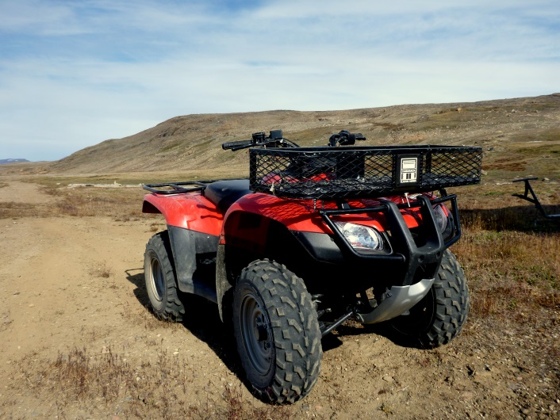
Photo: Thomas Juul-Pedersen
Permission is needed for using the Cramer machine.

Transport into the field – Young Sound

Winter (October-July)
At the moment we don’t have any winter transport equipment ready in Daneborg. Will be send there on purpose

Summer (July-October)
In the summertime, we use 3 boats from the station. There are two big rubber boats and a larger aluminum boat (Aage V. Jensen). For most of the work we use the Aage V. Jensen, because it equipped with an electrical winch and general designed for this kind of work.
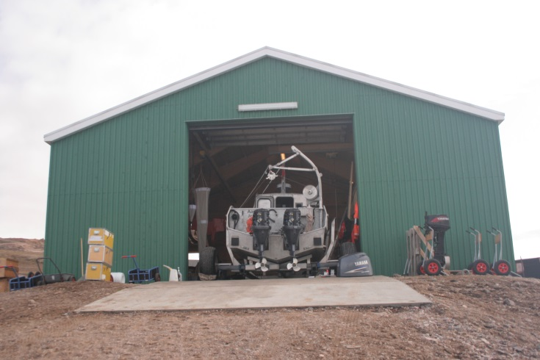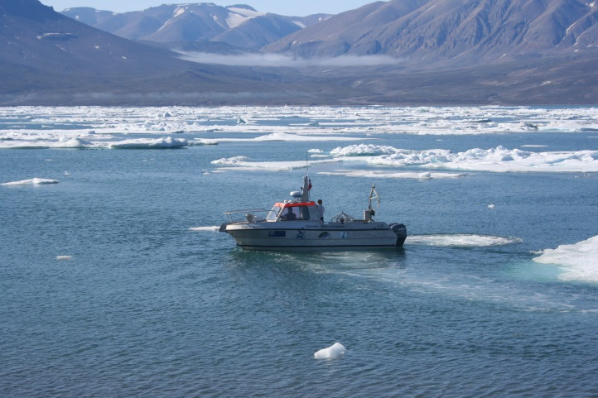
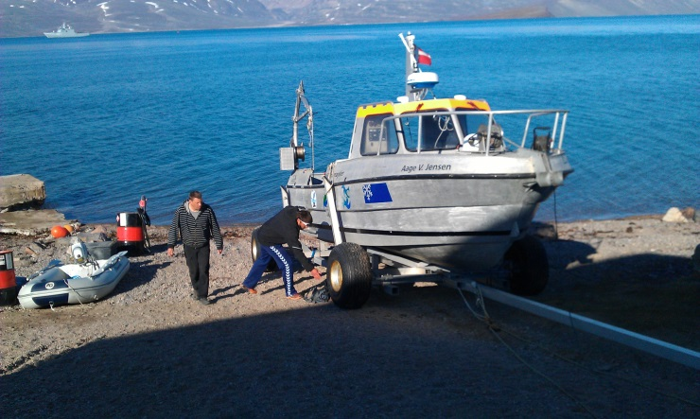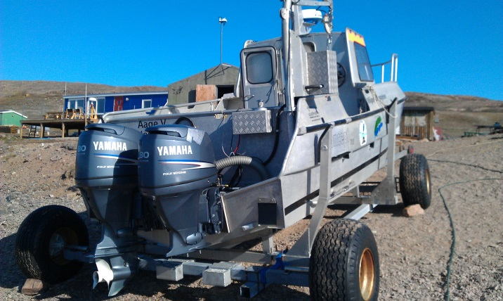
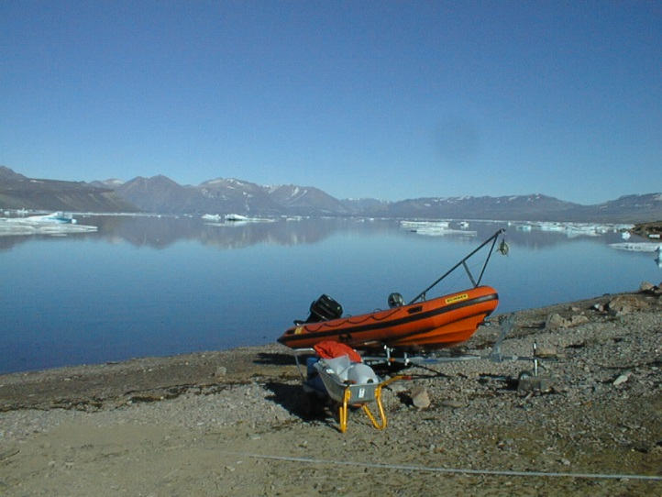 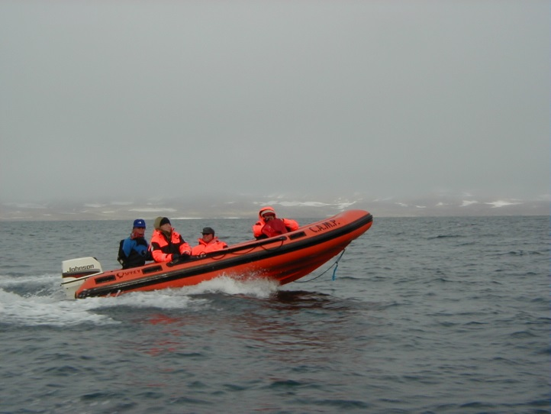
Photo: Søren Rysgaard Photo: Søren Rysgaard

Shipping cargo back to DK/Nuuk/Canada
Please download appendix 1 to your computer before you go to Daneborg – you will not be able to download in at the Daneborg station.

Shipping by air from Daneborg
All cargo must be labeled with the return address and mode of transport in appendix 1 whether it’s for shipment by air from Iceland or should go by ship from Iceland to the final destination. You must:
- pack you equipment in boxes with a single box weight below 50 kg
- label with the marks in Appendix 1 whether it’s for shipment by air or sea
- label with the label in Appendix 1 where to send the equipment
- finish the pro forma invoice in Appendix 1 on your cargo
When Appendix 1 is filled out you must send it to Egon erf@bios.au.dk and cc to Kibba kibba@norlandair.is from the Open Port Iridium on Daneborg.

Shipping by ship from Daneborg
The cargo must be labeled with the return address and mode of transport in appendix 1 whether it’s for shipment by ship after arriving in DK or for air freight after arriving in DK to the final destination (Shipments with final destination in DK will always be shipped by road to final destination internal in DK). You must:
- pack you equipment in boxes and fix it to pallets for shipment
- label with the marks in Appendix 1 whether it’s for shipment by air or sea
- label with the label in Appendix 1 where to send the equipment
- finish the pro forma invoice in Appendix 1 on your cargo
When Appendix 1 is filled in please send it to Egon erf@bios.au.dk from the Open Port Iridium on Daneborg

